Drilling rig
- Derrick: 1,250kip hook & 800kip setback
- Drawworks: 3,000HP
- Top Drive: 500T x 1,150HP
- 18,000 ft of 5-7/8” XT-57 drillpipe
- Mud Storage: 6,500 bbls system, 3,500 bbls mud & 3,000 bbls brine
- Powered catwalk to deliver R2/R3 tubulars to well center
- 15k stand handler
- Surface BOP stack: 13-5/8” 10M three ram & 5M annular BOP
- Subsea Isolation Device
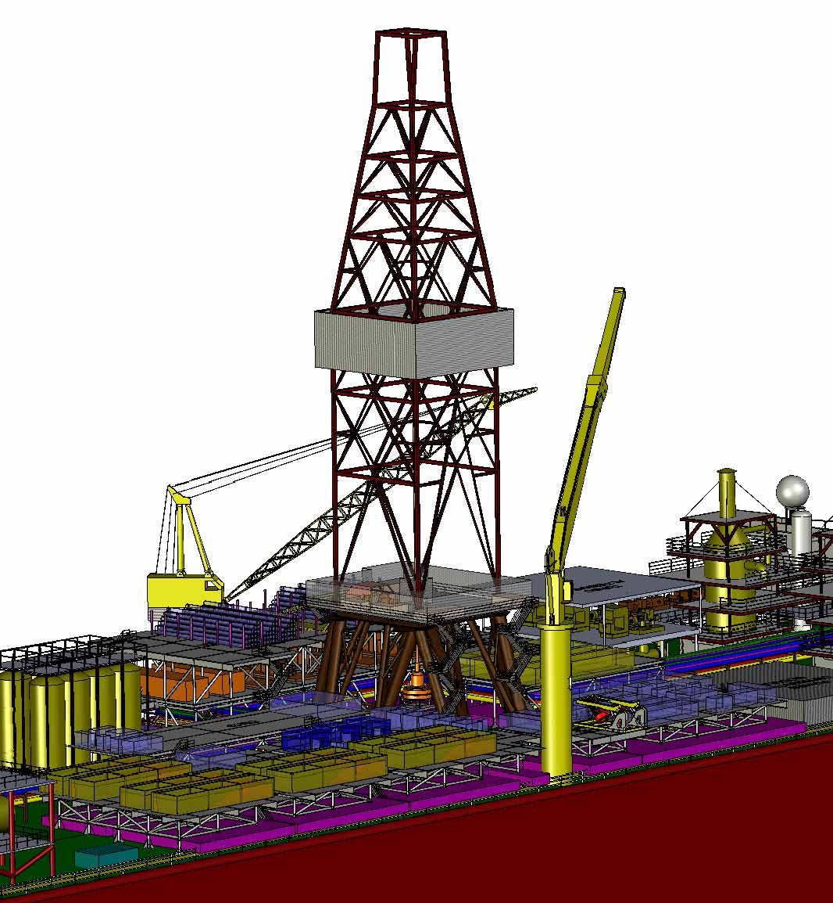

Multi-phase pumps
- 5,000 psig working pressure
- 600 PSI boost
- 35,000 blpd flowrate per pump
- 5,000 feet water depth
- Total module weight - 45 ton
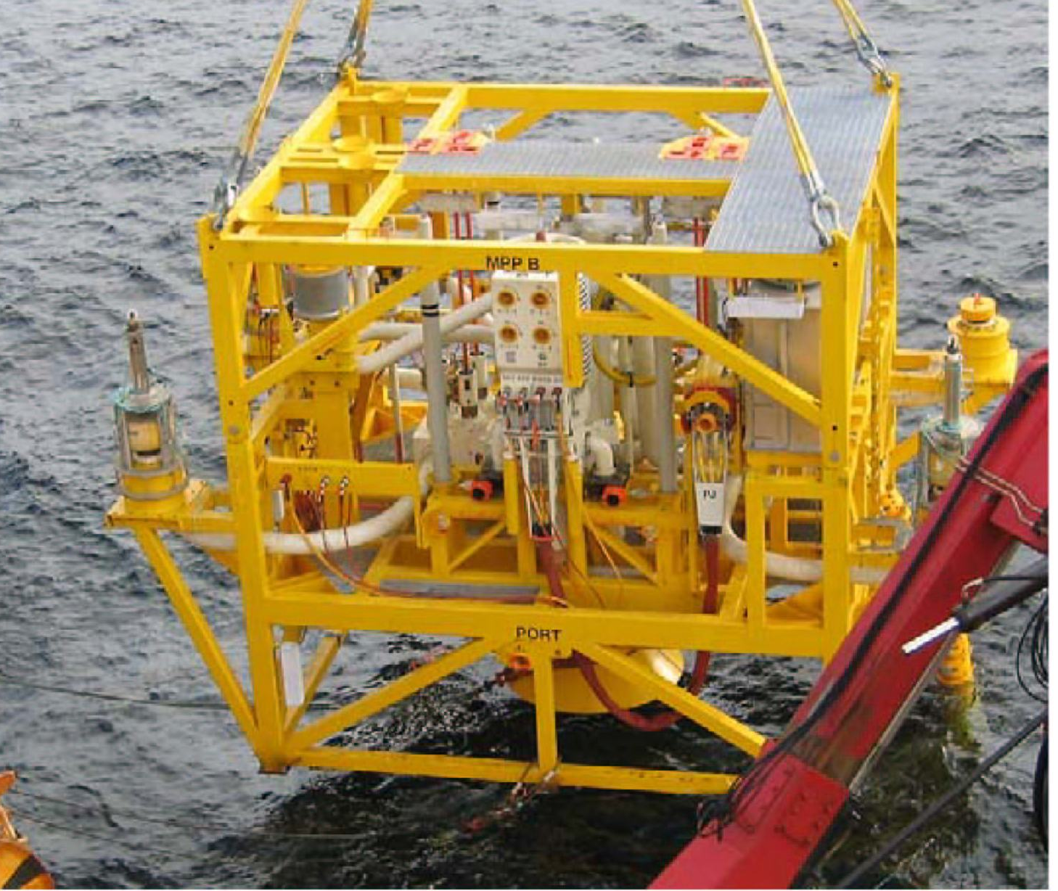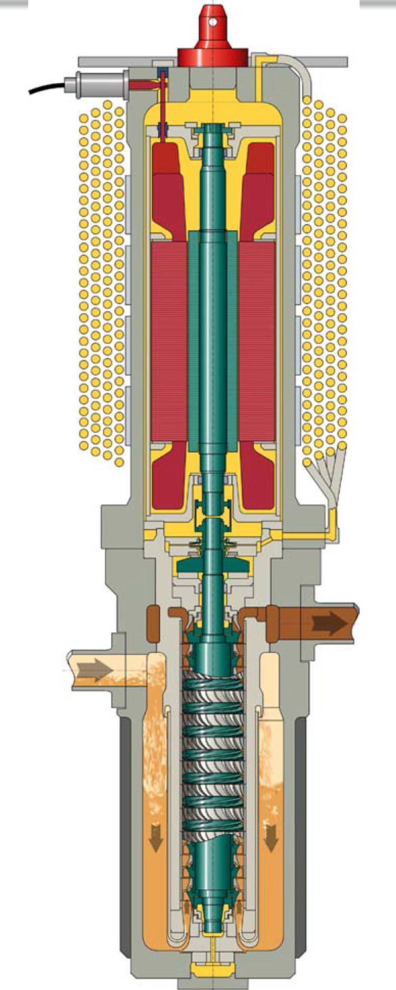

About the COMPANIES
Murphy West Africa, LTD.
Murphy West Africa, LTD. is Operator with 50% working interest.
Groupe SNPC
Societe Nationale Des Petroles du Congo (SNPC) owns 15% working interest.
PA Resources
PA Resources owns 35% working interest.
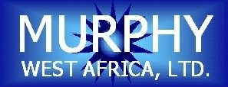

Murphy West Africa, LTD.
Immeuble Les Manguiers
4ème étage
B.P. 4264
Pointe Noire
Republique du Congo

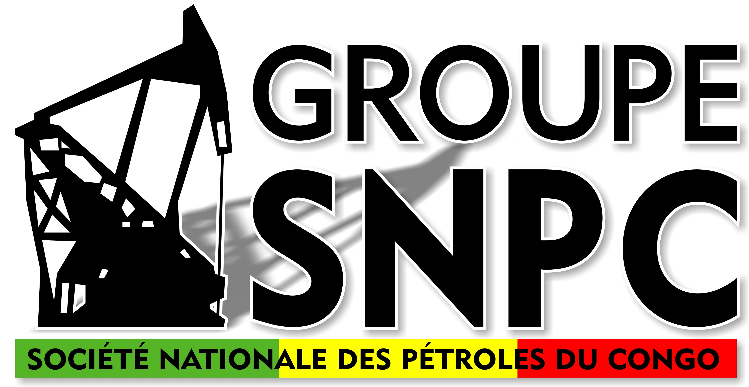

Groupe SNPC
Avenue Amilcar CABRAL
B. P. 188 - Brazzaville
République du Congo
Tél. : +(242) 81 09 64
Fax : +(242) 80 04 92

PA Resources AB
Kungsgatan 44, 3rd floor
SE-111 35 Stockholm
Sweden
Tel. : +46 8 21 83 82
Fax : +46 8 20 98 99

AZURITE FIELD DEVELOPMENT PROJECT

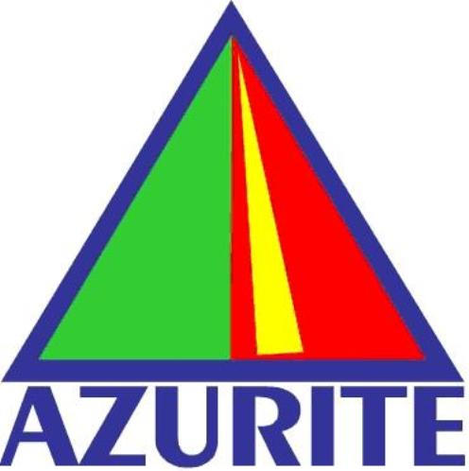

Industry’s First
FDPSO

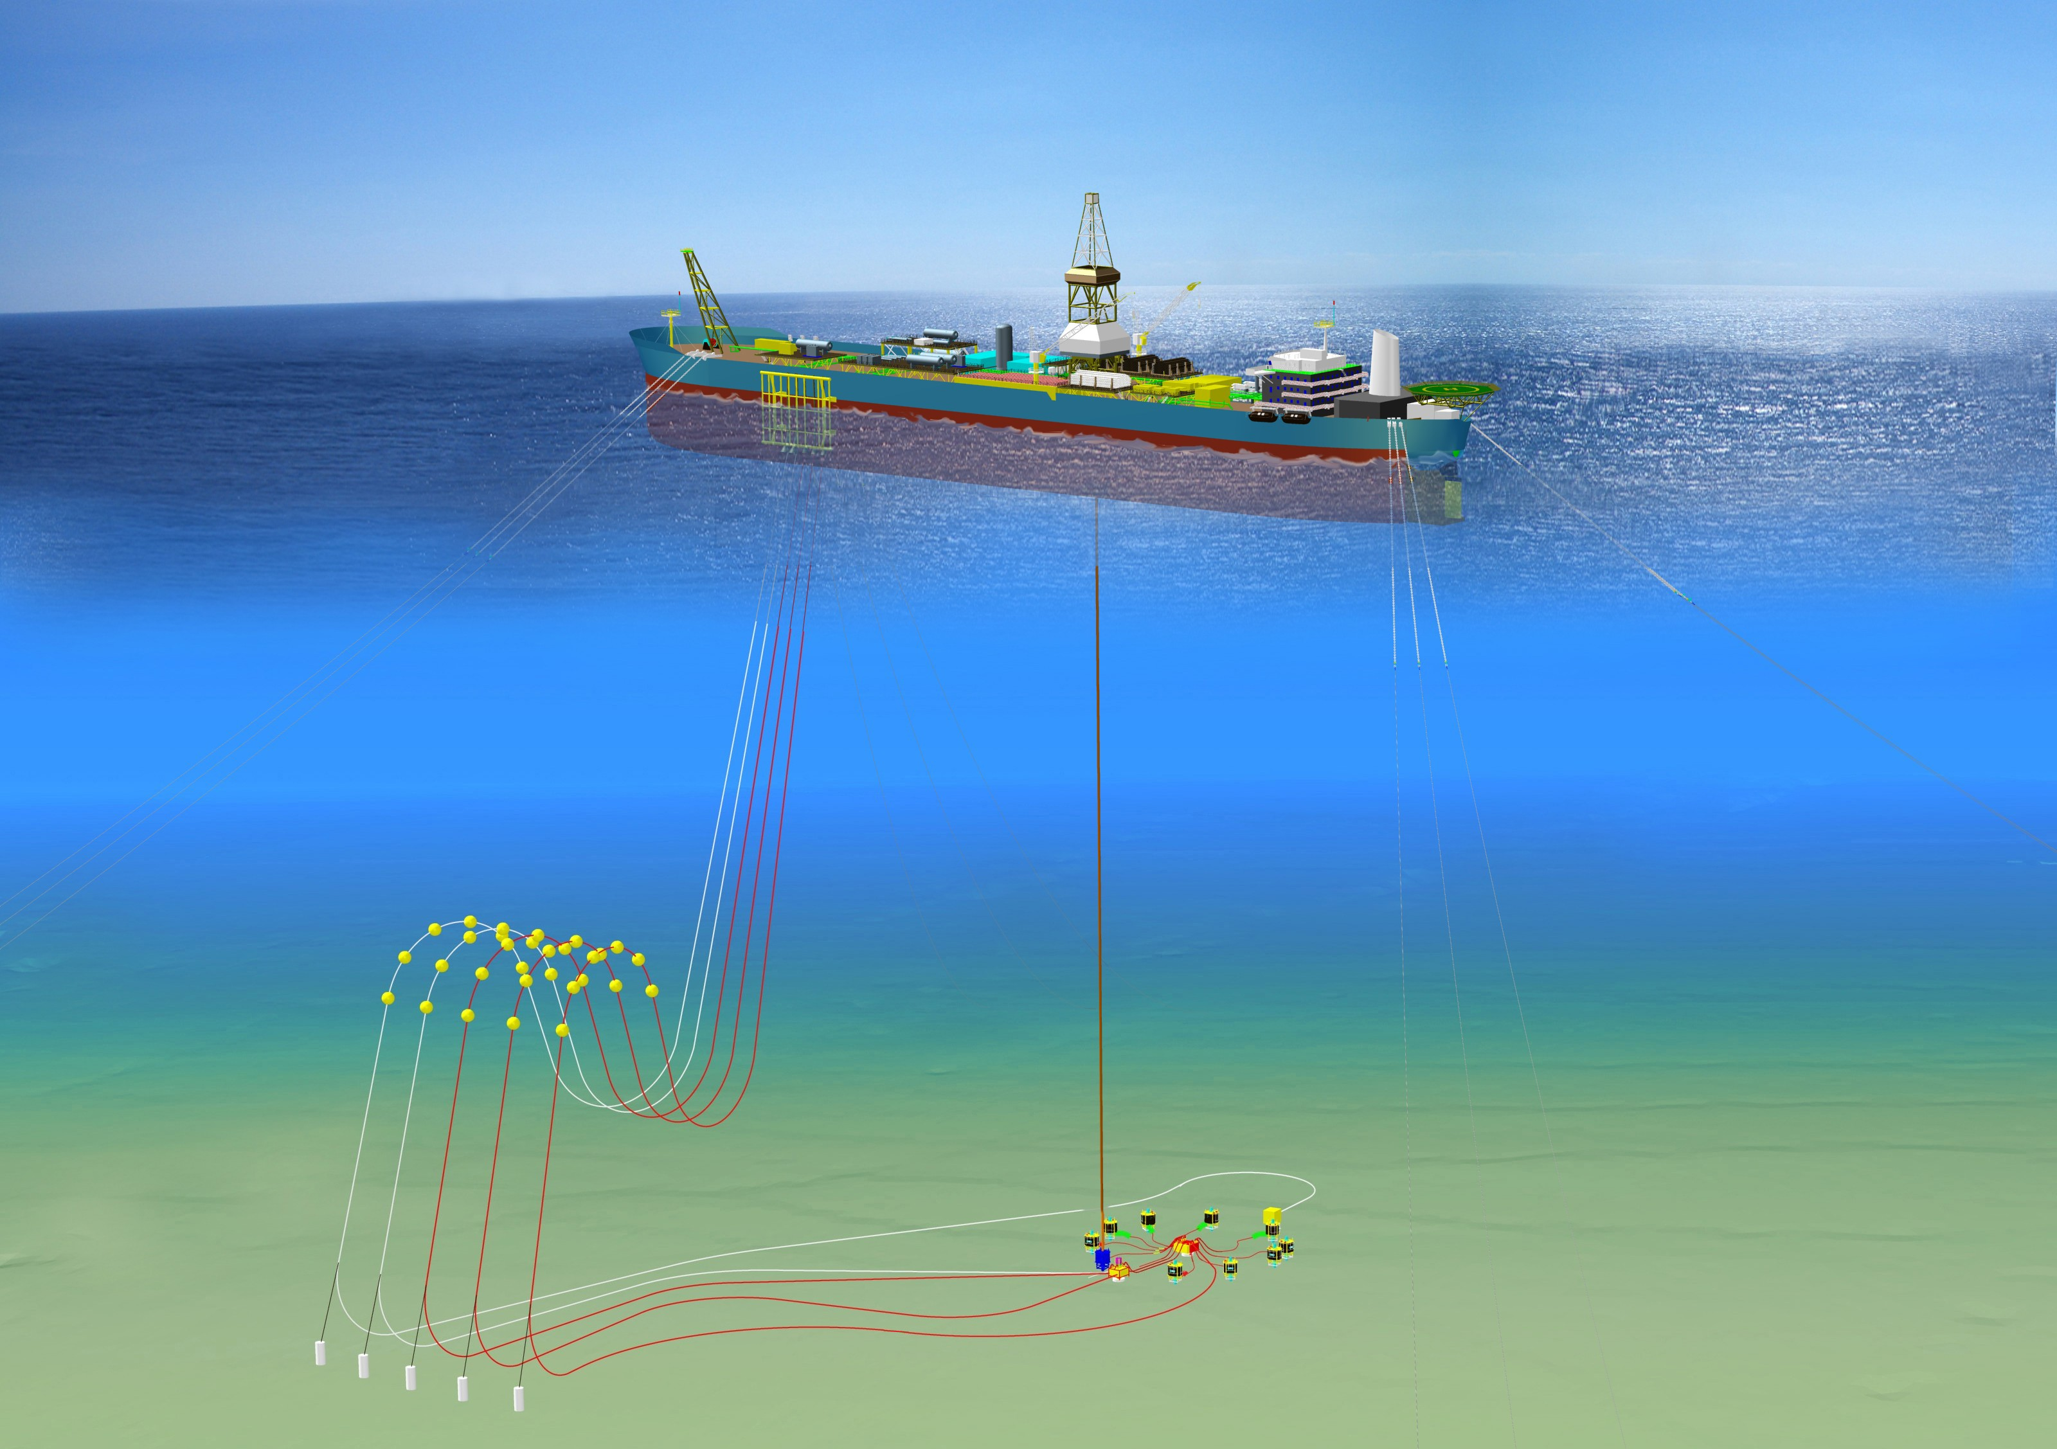

Azurite Project
Murphy West Africa, Ltd., Societe Nationale Des Petroles du Congo (SNPC) and PA Resources, AB are developing the Azurite Field located in block Mer Profonde Sud in 1380m of water, offshore The Republic of Congo. The Azurite discovery well was drilled in January 2005 and first oil is planned for the second quarter of 2009.
The field development consists of a spread moored Floating Drilling Production Storage and Offloading unit (FDPSO) tied to a subsea manifold. The concept of integrating a drilling unit into a FPSO is unique and involved cutting a moonpool in the vessel hull and mounting a land drilling rig over it on the vessel deck.
The subsea manifold has ten slots - six for oil and gas production and four for water injection. The subsea manifold is tied to the FDPSO by three flexible high pressure risers, two for production and one for water injection. The trees are vertical and tied to the subsea manifold by flexible well jumpers. A multiphase pump will provide artificial lift.
The FDPSO maximum process capacity is 40,000 bopd and 18 mmscfd. Storage capacity is 1.3 mm barrels of oil.

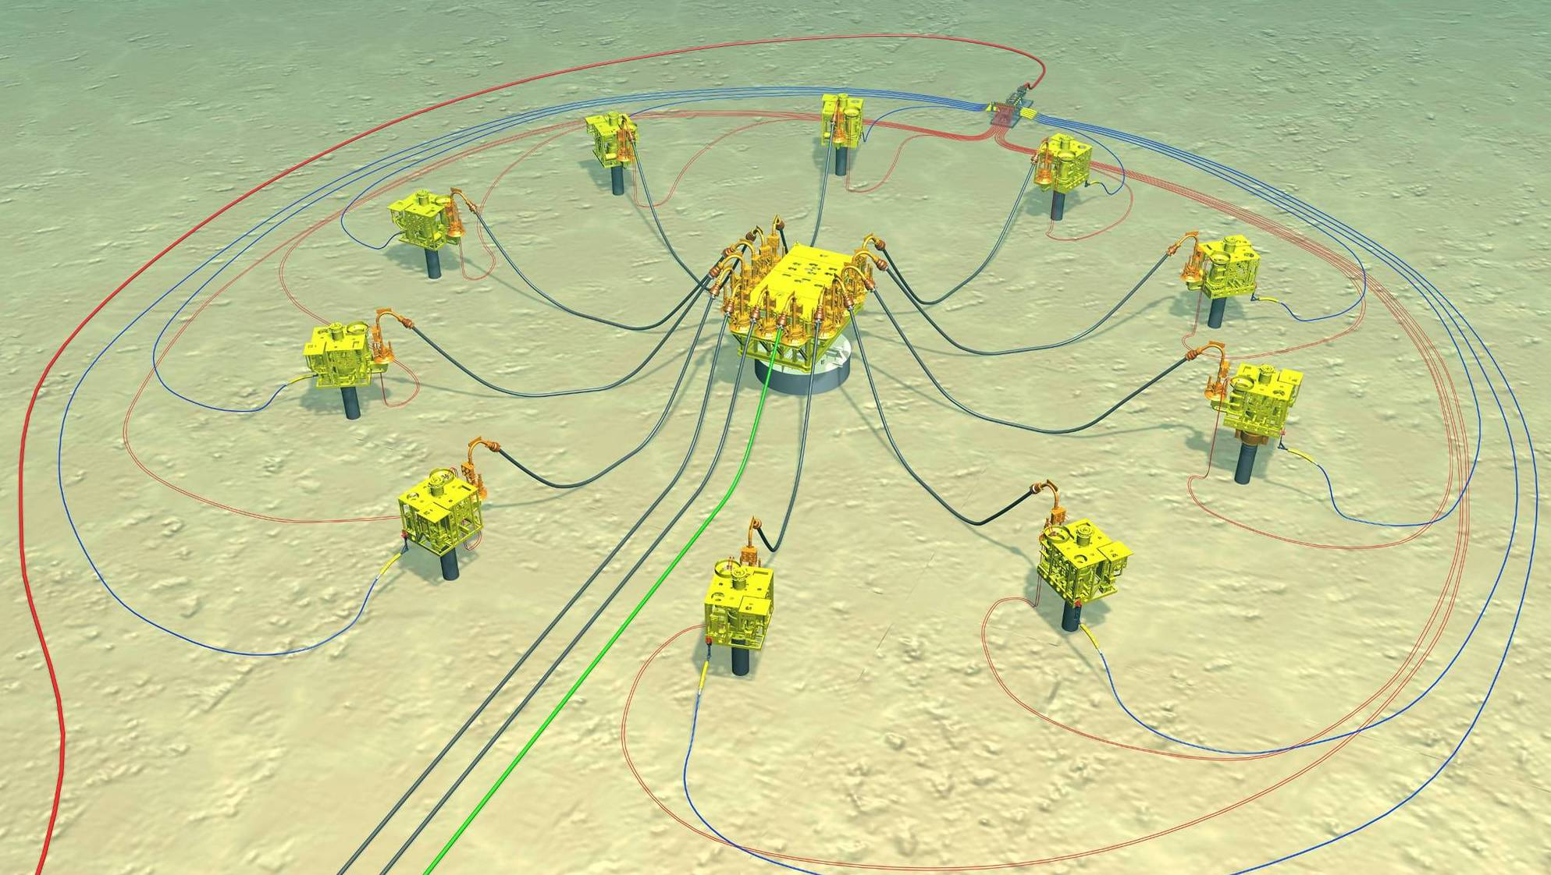

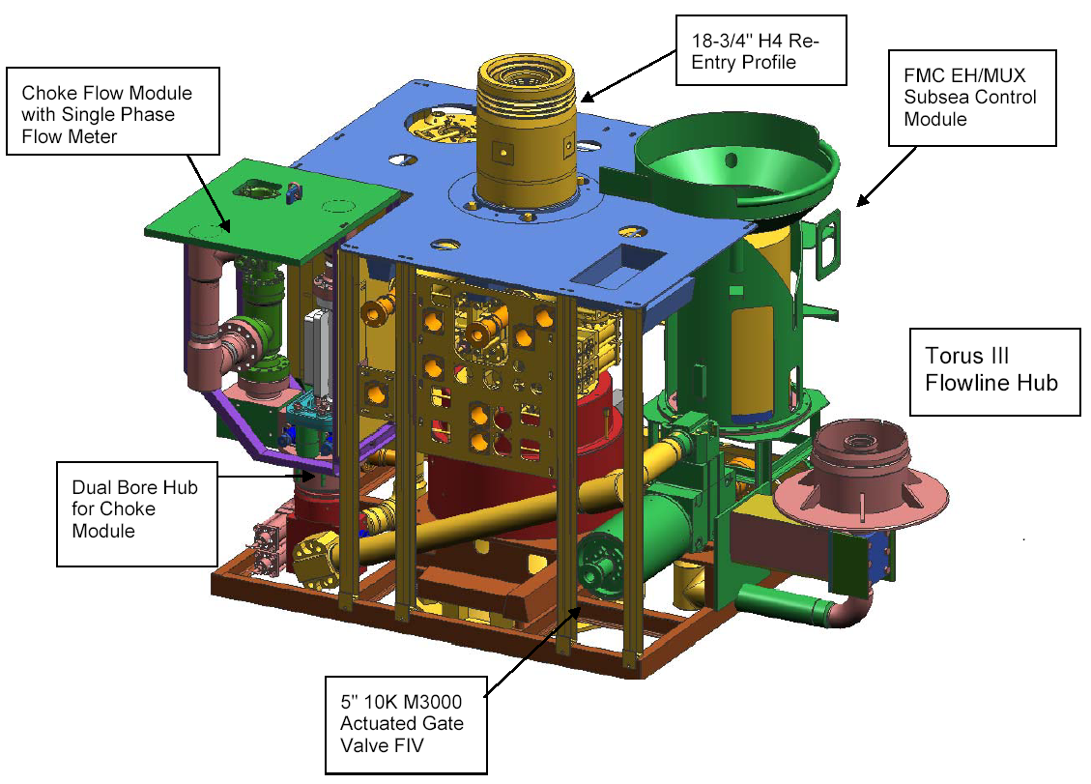

Vertical
Deepwater Tree

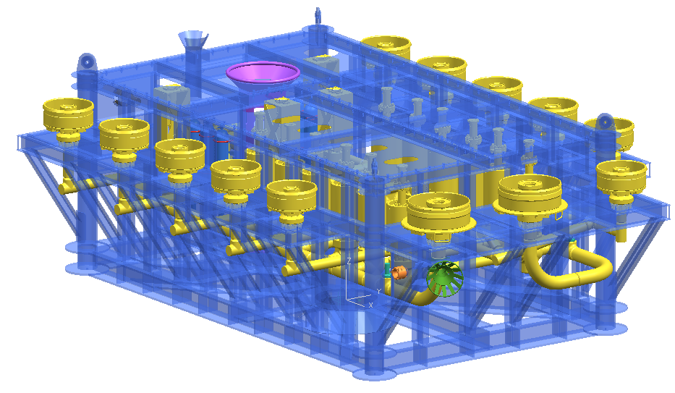

Subsea Production and
Water Injection Manifold

